This is results page displayed to the voter after the admin ends the election.
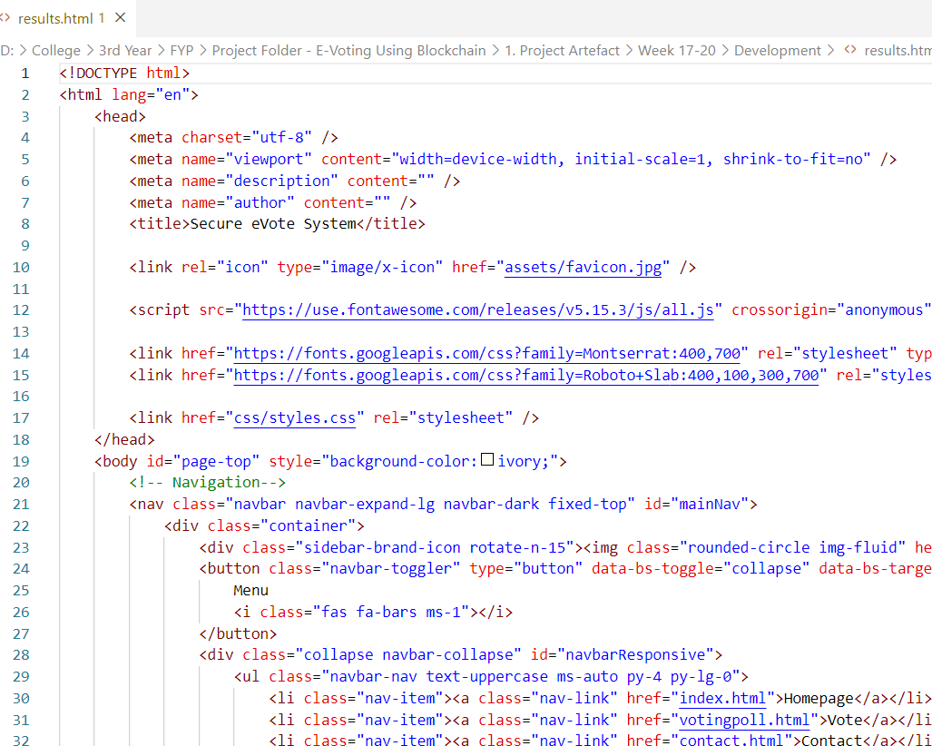

This is the jqplot for pie chart. It is used in voters overview page and it displays the pie chart in that page.
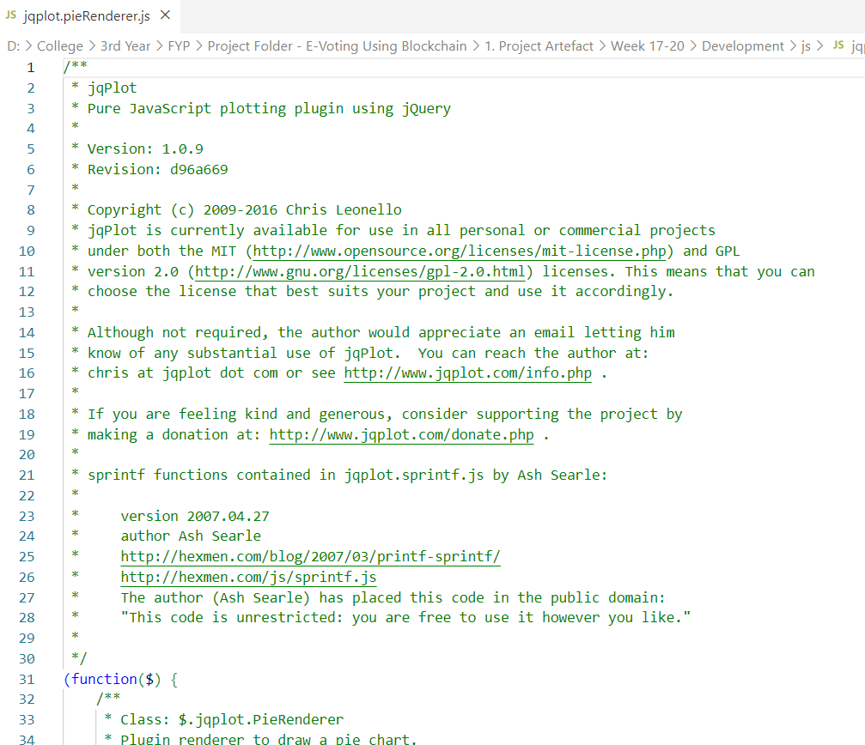

This is the front-end part of voter login. It provides the UI for voter login.
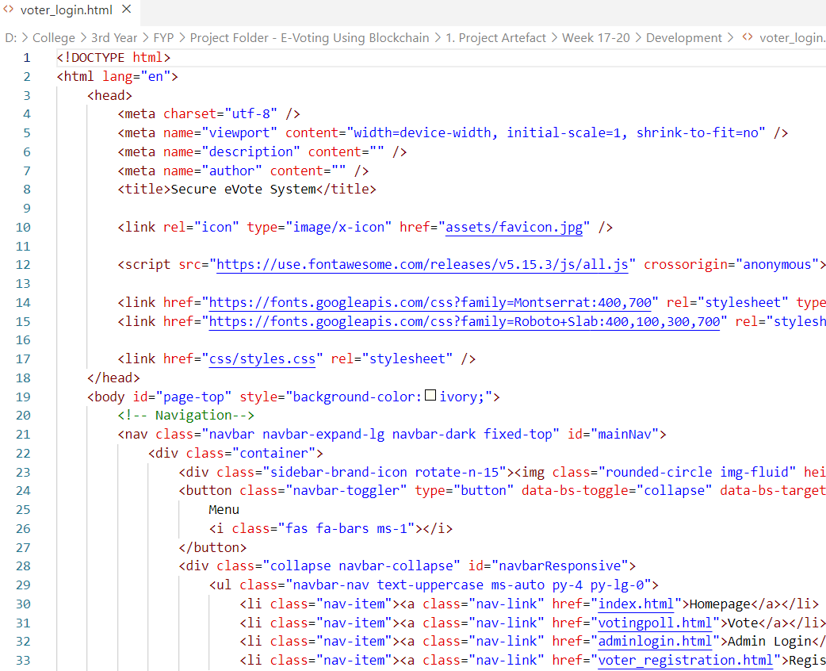

This is the manage voting page.
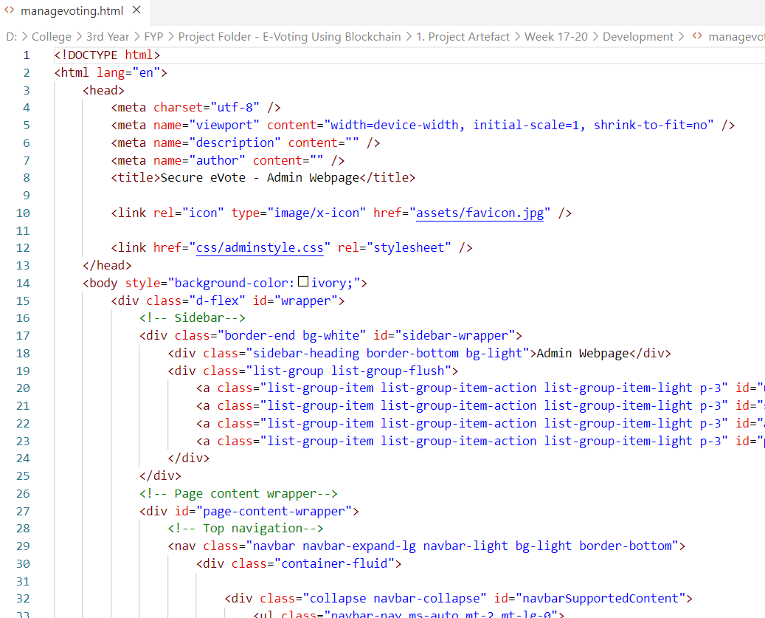

This is the voting poll page. It is displayed to the voter after the voter has logged in successfully. It displays different message/ texts in different situatons.
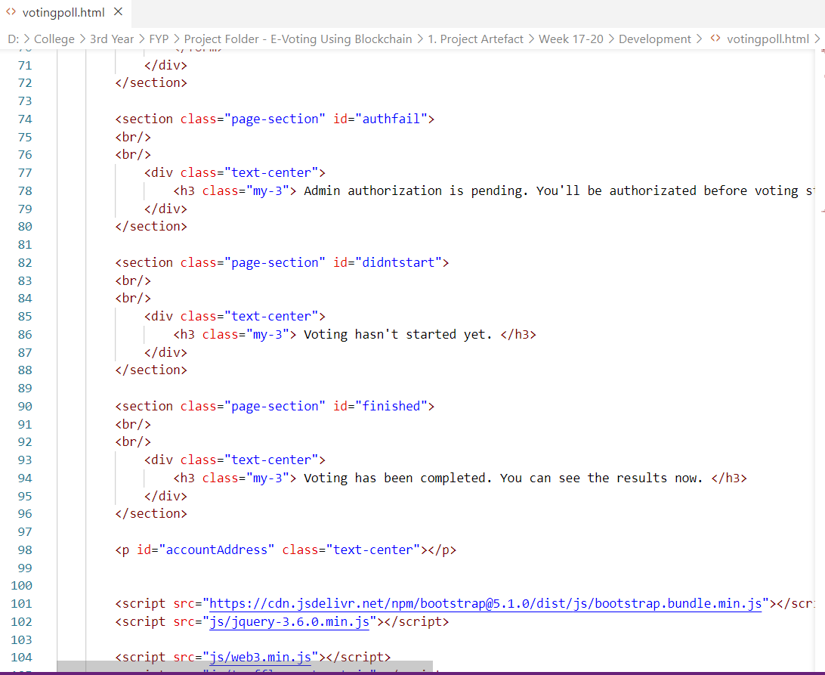

This is how the UI looks like without any function running.
